Module 8 Assignment

Data Warehouse:

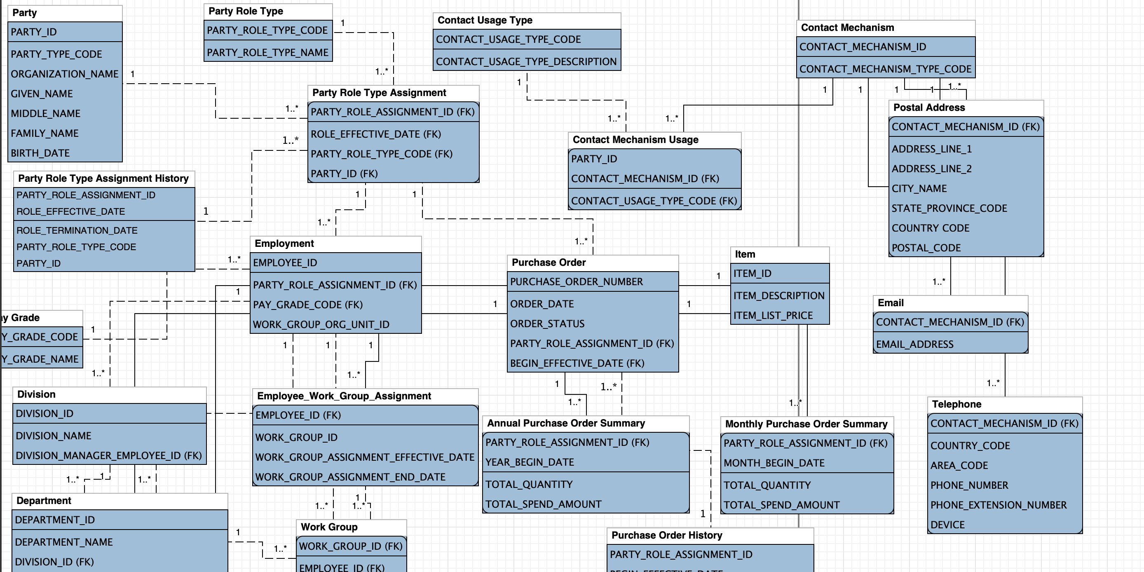

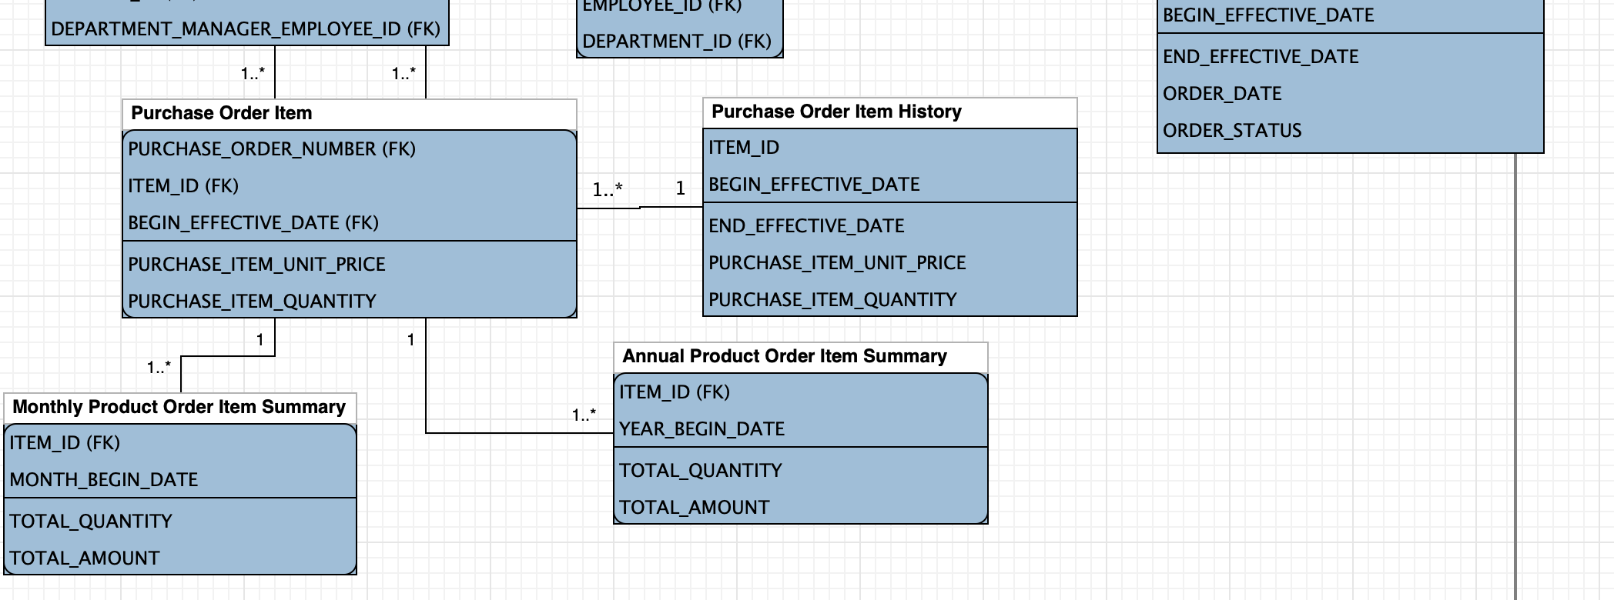

Data mart:

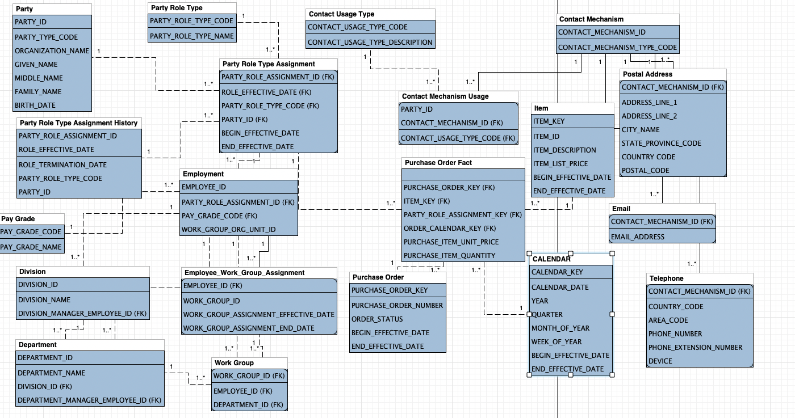

Explanation:

Full history is kept for the table related to Purchase Order Fact. Since I think that the Purchase Order is the most important table to create a data mart/data warehouse, for the sake of analyzing customer purchasing behavior.